GlobalSight
Installation Guide

Version 7.1

3rd Party Components
For Ubuntu Server (Version 8.04 LTS)
Open source initiative for
managing, translating &
delivering global content

Table of Contents
Table of Contents ii
Passwords for GlobalSight Components iii
Prerequisites 1
Install the MySQL Database Server 2
Installing MySQL Version 5.1.25 2
Installing MySQL from tar.gz Packages 2
Configure the Database 3
Creating the GlobalSight Database and User using MySQL Command Line 5
Install JDK 1.6.0_07 6
Install OpenLDAP 2.3.39 7

Passwords for GlobalSight Components
When installing GlobalSight components, you will be defining passwords for MySQL, OpenLDAP. Therefore, for simplicity choose one cross-component password now that you will use for all these components.
Choose an 8-character password that is the combination of the company name and an integer.
For reference, the following is a list of usernames and passwords for all the GlobalSight components. The cross-component GlobalSight password is represented by <password> in the table below.
Component | Username | Password | Description
MySQL | root | root | Root-user for MySQL. “root” is the default password. The password for your MySQL installation may be different. You’ll need this for creating the GlobalSight MySQL resources.
MySQL | globalsight | <password> | The user that owns all the GlobalSight tables.
OpenLDAP | cn=root, o=globalsight.com | <password> | The root user of OpenLDAP
LDAP connection | ldap_connection | <password> | The username and password used by GlobalSight to connect to OpenLDAP for user and role information.

Prerequisites
Before the installation of these packages, you need to make sure the user who has the sudo privilege.

Install the MySQL Database Server

Installing MySQL Version 5.1.25
These instructions are for MySQL Database System Version 5.1.25. The instructions may vary for other versions of MySQL.

Installing MySQL from tar.gz Packages
- Pre-condition
Before the installation of the MySQL, please make sure the current user has the read/write privileges to the directory “/usr/local”.
Please make sure the current user has the sudo privileage.
- If you have other version‘s MySQL installed, you need to remove them with the following commands.
Type: sudo /etc/init.d/mysql stop
Type: sudo apt-get remove mysql-server
Type: sudo apt-get purge mysql-server
Type: sudo apt-get remove mysql-client
Type: sudo rm –f /etc/mysql/my.cnf
- Unpack the tar.gz file
Type: tar zxvf mysql-5.1.25-rc-linux-i686-icc-glibc23.tar.gz
- Copy the extracted directory to the /usr/local and create a soft link for the MySQL directory
Type: sudo cp –R mysql-5.1.25-rc-linux-i686-icc-glibc23 /usr/local
Type: cd /usr/local
Type: sudo ln –s mysql-5.1.25-rc-linux-i686-icc-glibc23 mysql
- Create user and group for MySQL
Type: useradd mysql
Type: sudo usermod –a –G mysql mysql
- Change the owner and group attributes of the files to the MySQL user.
Type: sudo chown –R mysql:mysql /usr/local/mysql-5.1.25-rc-linux-i686-icc-glibc23
- Go the MySQL directory
Type: cd mysql
- Run the script to set up MySQL's internal database
Type: sudo ./scripts/mysql_install_db --user=mysql
The following information will be poped up when the script improted successfully.
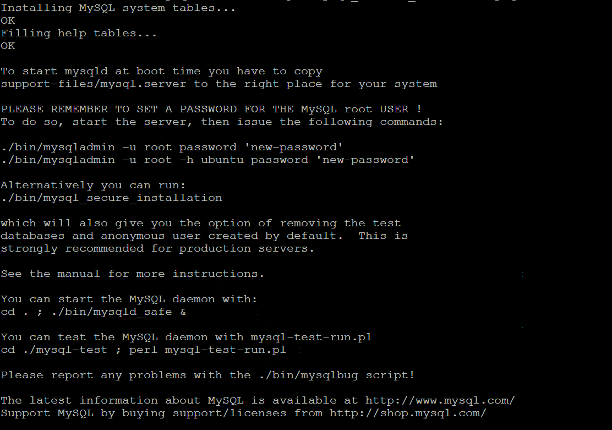
- Change the ownership for the MySQL directories and data files.
Type: sudo chown –R root .
Type: sudo chown –R mysql data
- Create start script for mysql
Type: sudo cp ./support-files/mysql.server /etc/init.d/
Type: sudo update-rc.d -f mysql remove
Type: sudo update-rc.d -f mysql.server remove
Type: sudo update-rc.d mysql.server defaults 98
- Set the path
Edit /etc/profile file and add the content as below
PATH=$PATH:/usr/local/mysql/bin
export PATH
Note: you need to re-login to make the PATH take effect.

Configure the Database
- Copy the default configuration file for the expected size of the database
Type: sudo cp support-files/my-medium.cnf /etc/mysql/my.cnf
Type: sudo chown mysql:mysql /etc/mysql/my.cnf
- Add or update variables under mysqld section in /etc/mysql/my.cnf
default-storage-engine=INNODB
lower_case_table_names=1
log-bin-trust-function-creators=1
max_allowed_packet = 16M
default-character-set=utf8
default-collation=utf8_general_ci
character-set-server=utf8
collation-server=utf8_general_ci
init-connect='SET NAMES utf8'
innodb_data_home_dir = /usr/local/mysql/data/
innodb_data_file_path = ibdata1:10M:autoextend
innodb_log_group_home_dir = /usr/local/mysql/data/
innodb_buffer_pool_size = 50M
innodb_additional_mem_pool_size = 2M
innodb_log_file_size = 5M
innodb_log_buffer_size = 8M
innodb_flush_log_at_trx_commit = 1
innodb_lock_wait_timeout = 500
max_connections = 500
- Add or update variables under client section in /etc/mysql/my.cnf
default-character-set=utf8
- Now you can start the MySQL server
Type: sudo /etc/init.d/mysql.server start

Creating the GlobalSight Database and User using MySQL Command Line
- Login to mysql as root
Type: mysql –u root –p<password> -h<MySQL Host Address>
There is no default password for the root user, so you can assess the database by
Type: mysql –u root
Grant the privileges and change the password for the root user
Type: grant all privileges on *.* to root@’localhost’ identified by ‘<password>’;
- Create GlobalSight database
Type: create database <GlobalSight Database Name>;
- If your database deployed on a standalone machine, grant the privileges to the user who is on the application server machine.
Type: Grant all privileges on <GlobalSight Database Name>.* to <user>@’<ip address>’ identified by ‘<password>’;
Type: flush privileges;
The command above will create the user if the user does not exist, If the user has been created and you don’t want to change the password for the user, you can omit the “identified by” part.
Type: Grant all privileges on <GlobalSight Database Name>.* to <user>@’<ip address>’
Type: flush privileges;
e.g. We assume that your created a database named “globalsight”, the ip address of your application server is “192.168.29.29”, the user name is “globalsight”, and the password is “password”. Then, the command should be:
Type: grant all privileges on globalsight.* to globalsight@’192.168.29.29’ identified by ‘password’;
Type: flush privileges;
- If your database deployed on a same machine with the application server.
Type: Grant all privileges on <GlobalSight Database Name>.* to <user>@’localhost’ identified by ‘<password>’;
Type: flush privileges;
e.g. We assume that your created a database named “globalsight”, the user name is “globalsight”, and the password is “password”. Then, the command should be:
Type: grant all privileges on globalsight.* to globalsight@’localhost’ identified by ‘password’;
Type: flush privileges;

Install JDK 1.6.0_07
- Add the executable attribute to the file
Type: chmod a+x jdk-6u7-linux-i586.bin
- Extract the bin file
Type: sudo ./jdk-6u7-linux-i586.bin
- Create the directory for java if it is not exist.
Type: sudo mkdir /usr/local/java
- Copy the extracted directory to the /usr/local/java
Type: sudo cp -R jdk1.6.0_07 /usr/local/java/
- Set the file attribute
sudo chmod -R a+w /usr/local/java/jdk1.6.0_07/jre/lib/ext
- Set the JAVA_HOME and PATH
Edit /etc/profile file and add the content as below:
JAVA_HOME=/usr/local/java/jdk1.6.0_07
export JAVA_HOME
PATH=$PATH:$JAVA_HOME/bin
export PATH
Note: you need to re-login to make the PATH take effect.

Install OpenLDAP 2.3.39
- Pre-condition
- Configure apt
If your apt-get can update and install from internet, install gcc/libc6-dev/make directly.
If your apt-get cannot update and install from internet, please copy all the files (including all hidden files) from the Ubuntu installation cd to your disk(e.g. /usr/local/software/iso)
e.g.
Mount the data from the cdrom to your local disc
Type: sudo mkdir /mnt/media
Type: sudo mount /dev/cdrom /mnt/media
Type: sudo cp –R /mnt/media/* /usr/local/software/iso
Edit the /etc/apt/sources.list, remove all the unnecessary items and add the below content to this file.
deb file:/usr/local/software/iso hardy main
- Install gcc/libc6-dev/make
Before the installation of the OpenLDAP, please make sure the following packages have been installed.
Gcc
Type: sudo apt-get install gcc
Libc6-dev
Type: sudo apt-get install libc6-dev
Make
Type: sudo apt-get install make
- Install Berkeley DB
  - Go to the directory which you put the BerkeleyDB tar file and extract the tar.gz file
Type: tar zxvf db-4.5.20.tar.gz
  - configure and make the BerkeleyDB
Type: cd db-4.5.20/build_unix/
Type: sudo ../dist/configure
Type: sudo make && sudo make install
Type: echo “/usr/local/BerkeleyDB.4.5/lib/” | sudo tee –a /etc/ld.so.conf
Type: sudo ldconfig
  - The BerkeleyDb will be installed in /usr/local/BerkeleyDB.4.5
- Install OpenLDAP
  - Go to the directory which you put the OpenLDAP tar file and extract the tar.gz file
Type: tar zxvf openldap-stable-20071118.tar
  - Configure and make the OpenLDAP
Type: cd openldap-2.3.39
Type: sudo env CPPFLAGS="-I/usr/local/BerkeleyDB.4.5/include" LDFLAGS="-L/usr/local/BerkeleyDB.4.5/lib" ./configure --prefix=/usr/local/openldap --enable-ldbm
Type: sudo make depend
Type: sudo make && sudo make install
  - Add user and set directory attribute for OpenLDAP
Type: sudo useradd openldap
Type: sudo chown -R openldap /usr/local/openldap
  - Create service for OpenLDAP(optional)
Unzip the file GlobalSight.zip and go to the directory ./install/data/linux
Copy the file slapd.sh to the directory /etc/init.d
Type: sudo update-rc.d slapd.sh defaults 98
  - Set the path for OpenLDAP
Edit /etc/profile file and add the content as below:
PATH=$PATH:/usr/local/openldap/sbin
export PATH
Note: you need to re-login to make the PATH setup take effect.
  - Start OpenLDAP
Type: sudo /usr/local/openldap/libexec/slapd –u openldap

